CYCLE 1

PROGRAM 1

AIM : Write a program that promt the user to enter hs first name and last name and then display a message “Greeting!!” ?

fname=input("Enter your first name: ")
lname=input("Enter your last name: ")
print("Greetings!!",fname,lname)

Output :

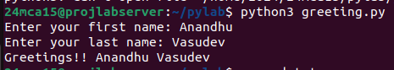

PROGRAM 2

AIM : Write a program to demonstate diffrent number data types in python ?

x,y,z=2,3.3,3+2j
print("Type of x= ",type(x))
print("Type of y= ",type(y))
print("Type of z= ",type(z))

Output :
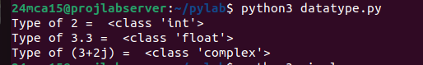

PROGRAM 3

AIM : Write a program to calculate the area of a circle by reading input from the user

r=float(input("Enter the radius of the circle :"))
area =3.14*r*r
print("Area of the circle =",area)

Output :
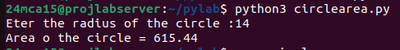

PROGRAM 4

AIM : Write a program to calculate the salary of an employee given his basic pay ,HRA = 10% of the basicpay,TA =5 % of basc pay ?

bp=float(input("Enter the basic pay of the employee :"))
hra=0.10*bp
ta=0.05*bp
salary=bp+hra+ta
print("Salary of the employee is : ",salary)

Output :
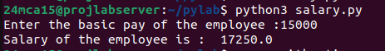

PROGRAM 5

AIM : Write a python progarmm to perform arithmetic operations on two integer numberv ?

x=int(input("Enter the first number :"))
y=int(input("Enter the second number :"))
print("Sum : ",x,"+",y,"=",x+y)
print("diffrence : ",x,"-",y,"=",x-y)
print("Multiplication : ",x,"*",y,"=",x*y)
print("Division : ",x,"/",y,"=",x/y)
print("Reminder : ",x,"%",y,"=",x%y)

Output :
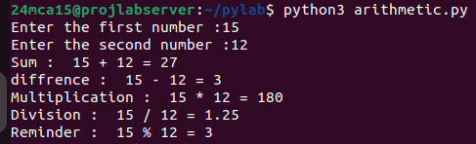

PROGRAM 6

AIM : Write a python program to get a string which is n (non-negative integer)copies of a given string ?

str = input ("Enter a string : ")
n = int(input("Enter the number (positive) of copies : "))
copy=str*n
print(copy)

Output :

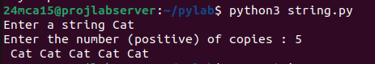
PROGRAM 7

AIM : Program to accept an integer n and compute n+nn+nnn

a=input("Enter a Number : ")
print(a,a*2,a*3)
sum=int(a)+int(a*2)+int(a*3)
print("Sum = ",sum)
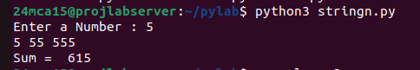
Output : PROGRAM 8

AIM : Progarm to find largest number of three number ?

a=int(input("Enter First Number"))
b=int(input("Enter Second Number"))
c=int(input("Enter Third Number"))

if a>b and a>c:
print(a,"is largest")
elif b>a and b>c:
print(b,"is largest")
else:
print(c,"is largest")

Output :

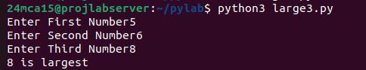
PROGRAM 9

AIM : Program to determin whether a year is a leap year or not ?
year = int(input("Enter the year : "))
if(year%400==0):
print("Leap Year")
elif(year%100==0):
print("Not a Leap Year")
elif(year%4==0):
print("Leap year")
else:
print("Not a Leap year")

Output:
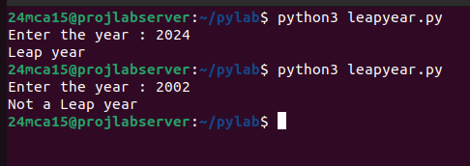
PROGRAM 10

AIM : Program to determine the rate of entry -ticket in a trade fair based on ages as follow ?

age=int(input("Enter the age : "))
if (age>=60):
print("Ticket Rate : 5")
elif(age<60 and age >=10):
print("Ticket rate : 10")
else:
print("Ticket Rate : 7")

Output :

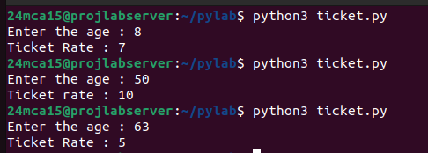
PROGRAM 11

AIM : Write a Program to solve quadratic equation ?

import math
print("Quadratic equaion ax^2+bx+c")
a=float(int(input("Enter value a : ")))
b=float(int(input("Enter value b : ")))
c=float(int(input("Enter value c : ")))
desr=(b*b)-(4*a*c)
if(desr==0):
print("Only one root value\n")
ans=(-b)/2*a
print("x =",ans)
elif(desr>0):
sqrtvalue=math.sqrt(desr)
ansone=(-b+sqrtvalue)/2*a
anstwo=(-b-sqrtvalue)/2*a
print("x1 = ",ansone)
print("x2 = ",anstwo)
else:
print("Complex Root !!")

Output :

